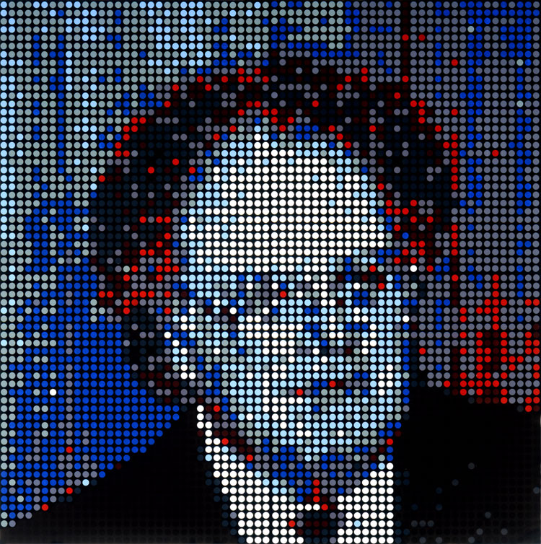

“About Faces” (14 December 2006) highlights a panorama of twelve portraits of Kolker’s ‘stars’ of science and mathematics, the arts and communication media, installed in a super-sized suite, 96 x 288 inches. Also included is a retrospective of paintings which demonstrate the artist’s maturation to painterly-ness while strictly adhering to his particular process.

What began as a procedural painting experiment about minimalism in 1980 has evolved into Kolker’s style of painting, a process which he calls ‘fracolor.’ Using waffle-glass at first and ultimately fractal computer programs, the artist fractionates, paints and silk-screens a grid circumscribing colored dots. His palette is based in both light optical and pigment color theories from which he has selected red, blue, green and yellow plus anachromics black and white. Although he still eschews mixing colors with each other, Kolker now does his own about-face. Creating shades, tints and tones by mixing color with black and white, Kolker exponentially expands the gamut of his palette in this portraiture show “About Faces.”

