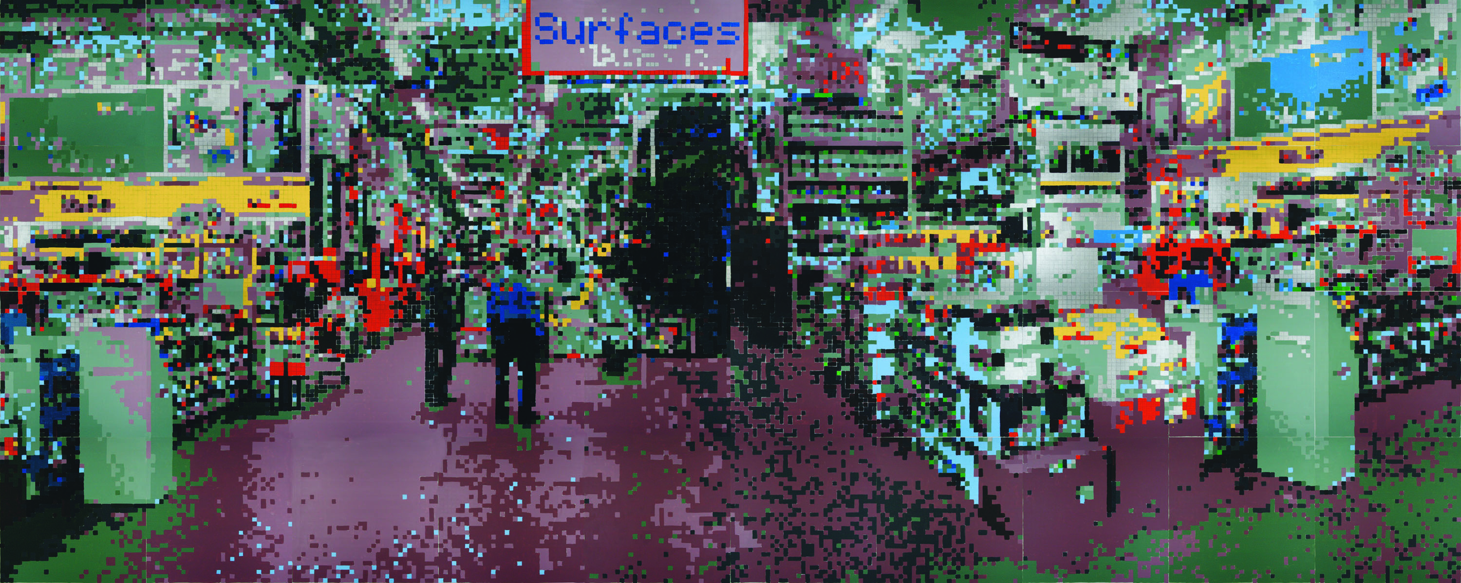

“Forms, spaces and surfaces… and colors, too” (December 20, 2007), is the continuation of Kolker’s experiment which tests and questions what we see in our contemporary world as influenced by computer and television screens filled with colors circumscribed by a black grid of dots.

Come and see the show to answer the experiment’s lead question:
“What effect, if any, does a black grid circumscribing colored dots have on your perception of form (the image), space (depth), surface (dimension) and the color itself?”

The experiment’s control, surfaces, 2007, is a supersized modular painting in forty parts (acrylic on canvas, 96 × 240 inches) depicting a warehouse superstore while suggesting a visual paradigm of our commercial culture for the sale and purchase of goods. Kolker, as both investigator and artist, lacks little when it comes to concept, meaning, narrative, history or policy in his works and broadcasts the “hidden meaning” of consumerism of durable products such as art. Now picture in your “mind’s eye” surfaces, 2007 as a supersized gallery, museum or auction house warehouse in the umbra of Andy Warhol, who has been known to espouse that “…department stores will become museums and… museums will become department stores.”

The surfaces, 2007 warehouse with its rows and tiers of merchandise are separated by aisles which create perspective. A left frontal view is iterated to the right, like the foldings of the oragamist or the planar rotations of the cubist. Hence, the title surfaces. The painting contains 43,560 painted squares in red, green, blue and yellow or their tints (mixed with white), shades (mixed with black) or hues (mixed with white and black) while eschewing mixing colors with each other. This process of fractionation and color preparation is called, by the artist, fracolor. The denouement is a unique aesthetic.

The painting which addresses the experiment’s question, surfaces, too, 2007 is based on a photograph (by Christopher Burke) of the control painting, in inkjet (using the Pantone Color-Cue matching system), iridescent white acrylic and a black silkscreen dot grid on canvas (forty parts, 96 × 240 inches). The control and experimental paintings are hung on adjoining walls for comparative viewing. The measuring instrument is the viewer.

Another control painting presbyopia, 2007, (gloss acrylic on canvas, sixteen parts, 96 × 96 inches) is a neocubist representation of familiar presidential aspirants.

Five paintings, blockablonsitis one – five, 2007, (acrylic and silkscreen ink on canvas, each four parts, 48 × 48 inches) are of recognizably dimensional cubes in vivid color and permit the viewer to evaluate the effects of color and the dot grid.

And as for the supersized ceiling mural, … lift up my eyes toward the mountains, 2007, (inkjet with black dot grid on canvas, thirty six parts, 144 × 144 inches), the foreshortening and dimensional perspective are “cathedralesque”… while the narrative is freedom, liberty and the future of the American dream… Josh, Jeff, Vanessa and Dana.

